Problem 1:
Define a class called Counter. An object of this class is used to count things so it records a count that is a non-negative whole number. Include methods to set the counter to 0, to increase the counter by 1, and to decrease the counter by 1. Be sure that no method allows the value of the counter to become negative. Also include an accessor method that returns the current count value, as well as a method that displays the count on the screen. Do not define an input method. The only method that can set the counter is the one that sets it to zero. Write a program to test your class definition. (Hint: you need only one instance variable).
/*
Name: Casey Carnnia
Date: 12.13.2012
Scope: Problem 1:
Define a class called Counter.
An object of this class is used to count things
so it records a count that is a non-negative whole number.
Include methods to set the counter to 0,
to increase the counter by 1,
and to decrease the counter by 1.
Be sure that no method allows the value of the counter to become negative.
Also include an accessor method that returns the current count value,
as well as a method that displays the count on the screen.
Do not define an input method.
The only method that can set the counter is the one that sets it to zero.
Write a program to test your class definition. (Hint: you need only one instance variable).
counterDemo

*/

public class Counter
{
//instance variables
private int counterVal = 0;

/**
Sets the counter to zero
*/
public void resetCounter()
{
counterVal = 0;
}
/**
Increase the counter by one
*/
public void increaseCounter()
{
counterVal = counterVal + 1;
}
/**
Decrease counter by one
But not bellow 0
*/
public void decreaseCounter()
{
if (counterVal > 0)
{
counterVal = counterVal - 1;
}
else
{
System.out.println("Counter is zero. A negative counter is not allowed.");
}

}
/**
Return the current counter value
*/
public int getCounterValue()
{
return counterVal;
}
/**
Print the current value to the screen
*/
public void tostringCounter()
{
System.out.println("Currently the counter reads: " + counterVal);
}

}//class END
/*
Name: Casey Carnnia
Date: 012.13.2012
Scope: Write a program to test your class definition: Counter
*/

public class counterDemo
{
//- declare the main method
public static void main (String[] args)
{
Counter myCounter = new Counter();
System.out.println("First value of counter after instantiating the new object is: " + myCounter.getCounterValue());

//show counter going up
for (int x = 0; x < 5; x++)
{
myCounter.increaseCounter();
System.out.println("Counter ++ " + myCounter.getCounterValue());
}
//ask counter to write to screen
System.out.println("we upped the counter 5 times, so:");
myCounter.tostringCounter();

//show counter going down
for (int x = 0; x < 5; x++)
{
myCounter.decreaseCounter();
System.out.println("Counter -- " + myCounter.getCounterValue());
}
//ask counter to write to screen
System.out.println("we downed the counter 5 times, so:");
myCounter.tostringCounter();
//test for negative value
System.out.println("Can counter go below 0? ");
myCounter.decreaseCounter();

//take counter up so we can use the reset method
for (int x = 0; x < 5; x++)
{
myCounter.increaseCounter();
System.out.println("Counter ++ " + myCounter.getCounterValue());
}
//ask counter to write to screen
System.out.println("we upped the counter 5 times, so now we can test the reset method:");
myCounter.tostringCounter();
myCounter.resetCounter();
System.out.println("What is the value of counter after resetCounter() was called? ");
myCounter.tostringCounter();
}//main END
}//class END
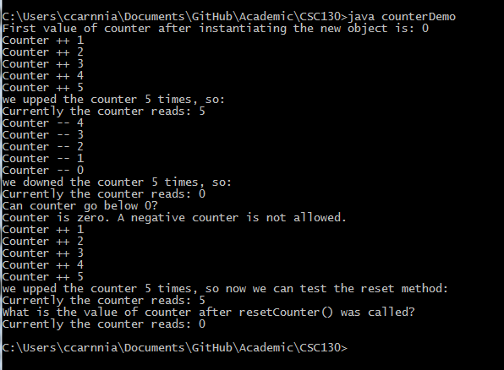

Problem 2:
Consider a class that could be used to play a game of hangman. The class has the following attributes:
- The secret word
- The disguised word, in which each unknown letter in the secret word is replaced with a question mark (?). For example, if the secret word is abracadabra, and the letters a , and b have been guessed, the disguised word would be ab?a?a?ab?a
- The number of guesses made
- The number of incorrect guesses
It will have the following methods:
- MakeGuess(c) guesses that character c is in the word
- getDisguisedWord returns a string containing correctly guessed letters in their correct positions and unknown letters replaced with ?
- getSecretWord returns the secret word
- getGuessCount returns the number of guesses made
- isFound returns true if the hidden word has been discovered.
Perform the following actions:
- Write a method heading for each method.
- Write preconditions and postconditions for each method.
- Write some Java statements that test the class.
- Implement the class.
- List any additional methods and attributes needed in the implementation that were not listed in the original design. List any other changes made to the original design.
- Write a program that implements the game of handgman, using the class you wrote for part d.

Problem 3:
Consider a class Movie that contains information about a movie. The class has the following attributes:
- The movie name
- The MPAA rating (e.g. G, PG, PG-13, R)
- The number of people that have rated this movie as a 1 (Terrible)
- The number of people that have rated this movie as a 2 (Bad)
- The number of people that have rated this movie as a 3 (OK)
- The number of people that have rated this movie as a 4 (Good)
- The number of people that have rated this movie as a 5 (Great)
Implement the class with accessors and mutators for the movie name and MPAA rating. Write a method addRating that takes an integer as an input parameter. The method should verify that the parameter is a number between 1 and 5, and if so, increment by one the number of people rating the movie that matches the input parameter. For example, if 3 is the input parameter, then the number of people that rated the movie as a 3 should be incremented by one. Write another method, getAverage, that returns the average value for all the movie ratings.
Test the class by writing a main method that creates at least two movie objects, adds at least five ratings for each movie, and output the movie name, MPAA rating, and average rating for each movie object.
Movie
_ name : String
_ raing: String
_ terrible: int
_ bad: int
_ ok: int
_ good: int
_ great: int
_ averageReview: double

+ getName(): String
+ setName(String newName): void
+ getRating(): String
+ setRating(String newRating): void
+ addRating(int rate): void
+ getAverage(): int
+ toString(): void
+ equals(Movie otherMovie): boolean

